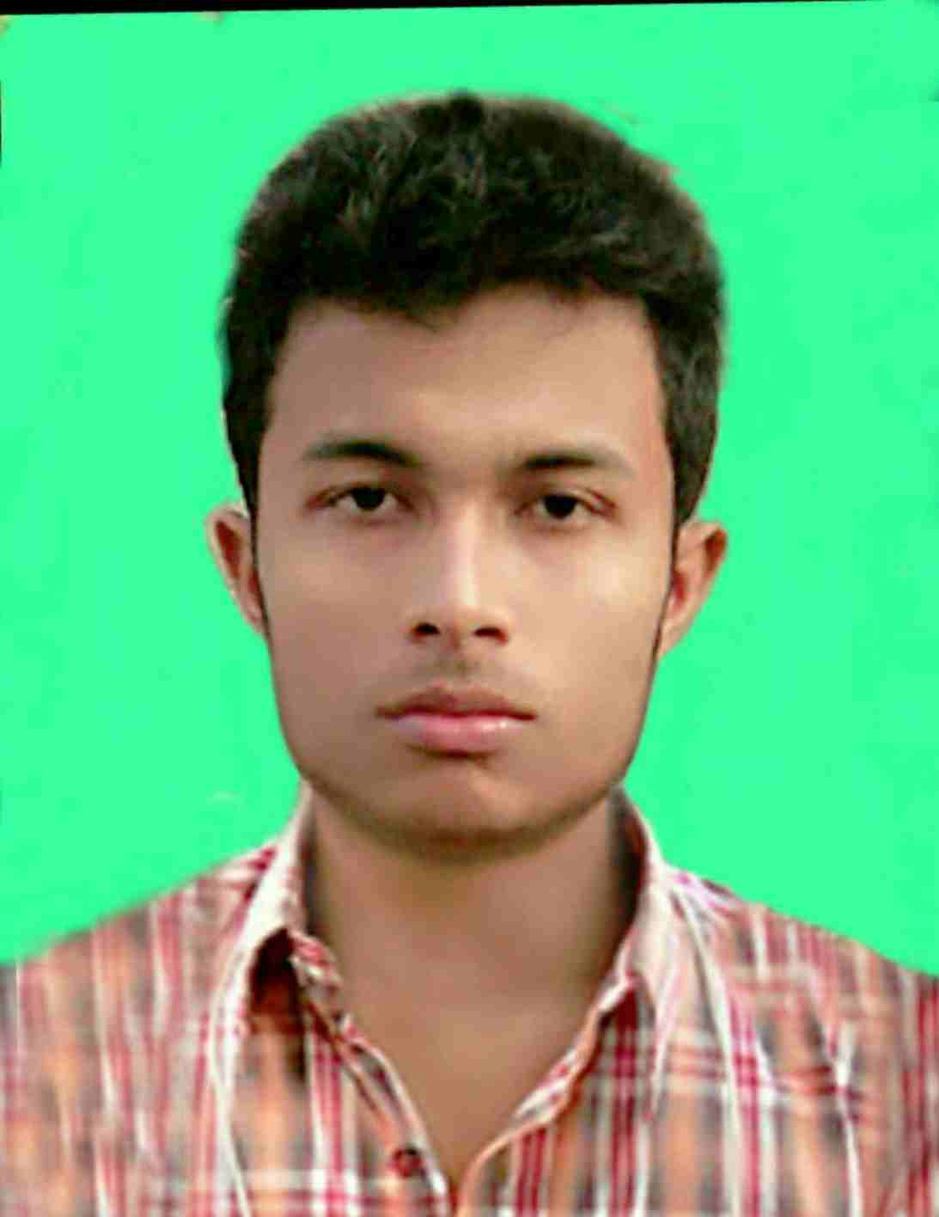**Cariculam vita**

**Of**

**Md Baijid Hossain**

Mobile: 01775051601

Email: [bayejidhossain47@gmai.com](mailto:bayejidhossain47@gmai.com)

**Present Address**

Ashulia,Building No 501,Dhaka

**Permanent Address**

Village: Shahagola, P.S: Atrai, Distric: Naogaon

**Career Objectiv**

To build up to career in well-eshtablished and environment friendly organigassion where acquired knowledge and expertise can be used efectively efficiently

**Self Assesment**

* A self-driven attitude,willingness to learn and a strong presenci of mind.
* Optimistic,confident benivolent.
* Energetic,devoted,cincere and hardwarking.
* Education free for all.

|  |  |  |  |  |
| --- | --- | --- | --- | --- |
| Name of exam | Group/Subject | Year of pssing | Institute/Versity | Result  GPA/CGPA |
| Diploma | Computer | 2020 | Bogura polytechnic institute | 3.50 out of 4.00 |
| SSC | Sciene | 2016 | Atrai technical school and collage | 5.00 out of 5.00 |

**Academic Qualification**

|  |  |  |
| --- | --- | --- |
|  |  |  |
| MS training senter,bogura | Founder & trainer | 2018-Present |
|  |  |  |

**Special skill**

**Languege Proficiency**

Confident Enough to communicate Both in English and Benga

|  |  |  |  |  |
| --- | --- | --- | --- | --- |
| Languege | Listaning | Reading | Writing | Speaking |
| Bengali | Excelent | Excelent | Better | Excelent |
| English | Excelent | Better | Better | Better |
| Urdu | Excelent | Better | Better | Excelent |

|  |  |  |
| --- | --- | --- |
| 1. | Opareting system | Windows xp,7,8.1,10 |
| 2. | Word processing | Microsoft word |
| 3. | Spread sheet analysis | MS exel,MS Access |
| 4. | Presentaion | MS power point |
| 5. | Adobe Photoshop | CC 2017 |
| 6. | Adobe illastrator | CC 2018 |
| 7. | Special | Internet browsing,SEO, video editing |

**Computer Literacy**

**Personal Information**

Name : Md Baijid Hossain

Father’s Name : Md. Mojibar Rahaman Mondal

Mother’s Name : Mst. Jibon Nesa

Date of Birth : 09 February 2000

NID : 19976410384000231

Height : 5.5”

Blood Group : B+

Weight : 54kg

Religion : Islam

Maritial : Unmarried

Nationality : Bangladeshi

The information stated above is true

Signature